MERN Application through Terraform and Ansible
Documentation

MERN Application through Terraform and Ansible
Name: Nivedha S
ID: 13487
Date: 29nd Aug 2026

Part 1: Infrastructure Setup with Terraform
- Clone the project and configure aws
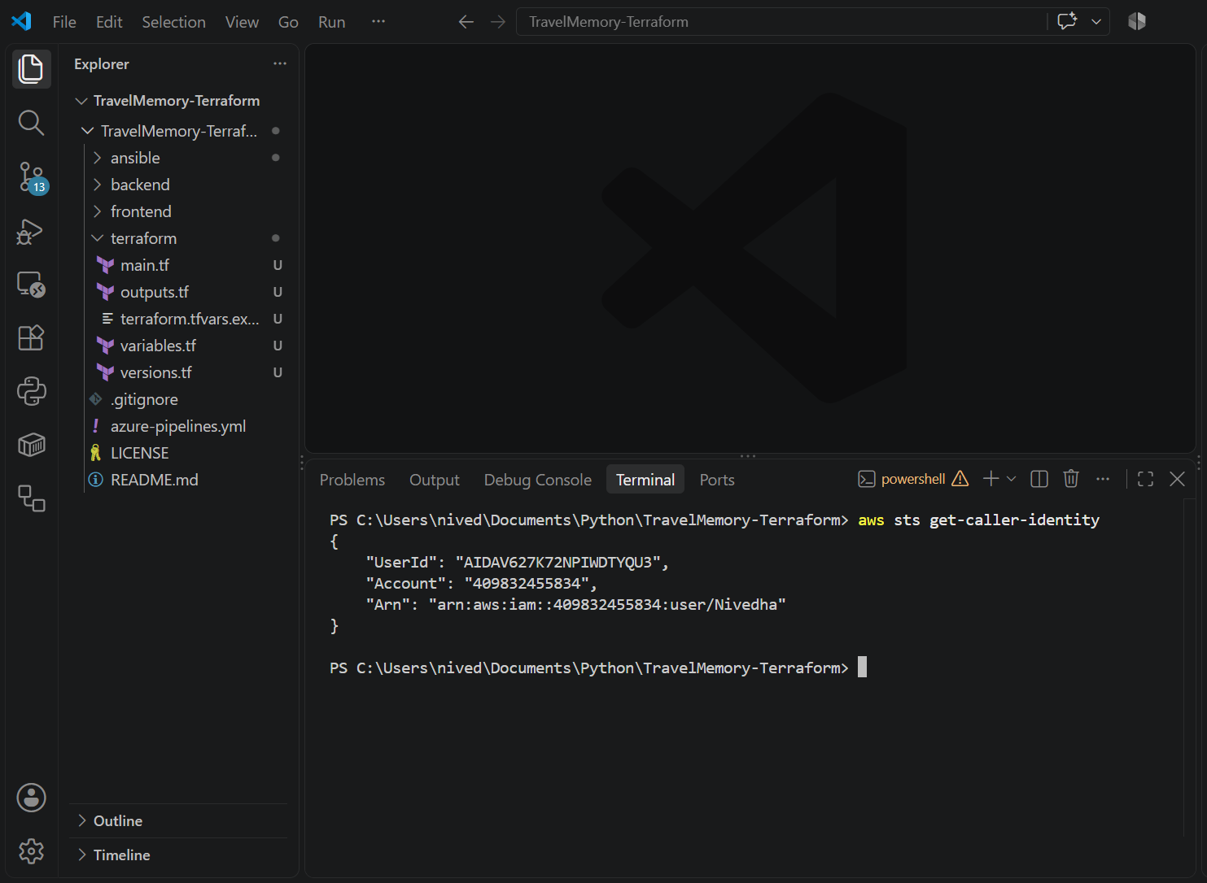
- NPM Install and start:
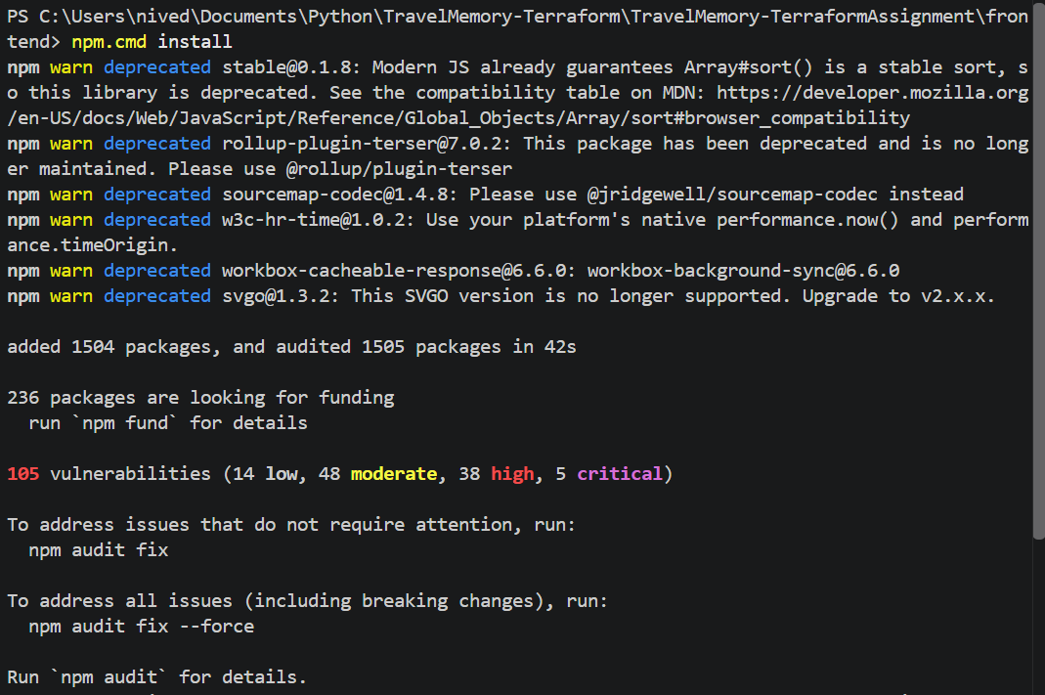
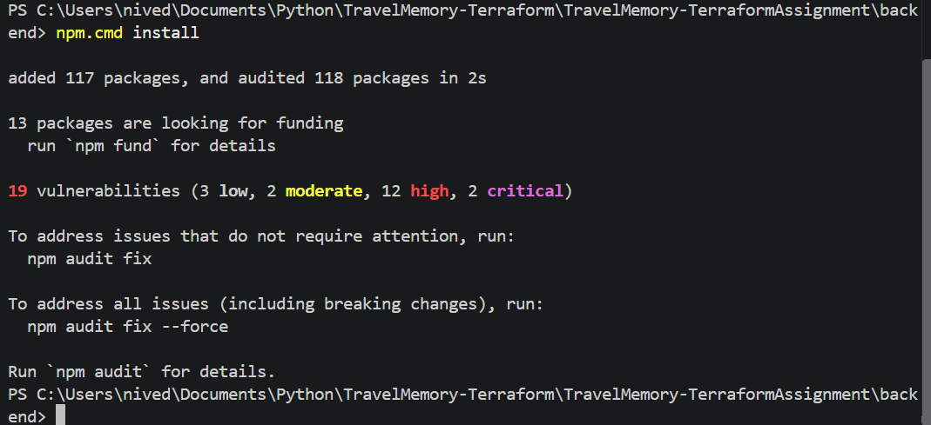
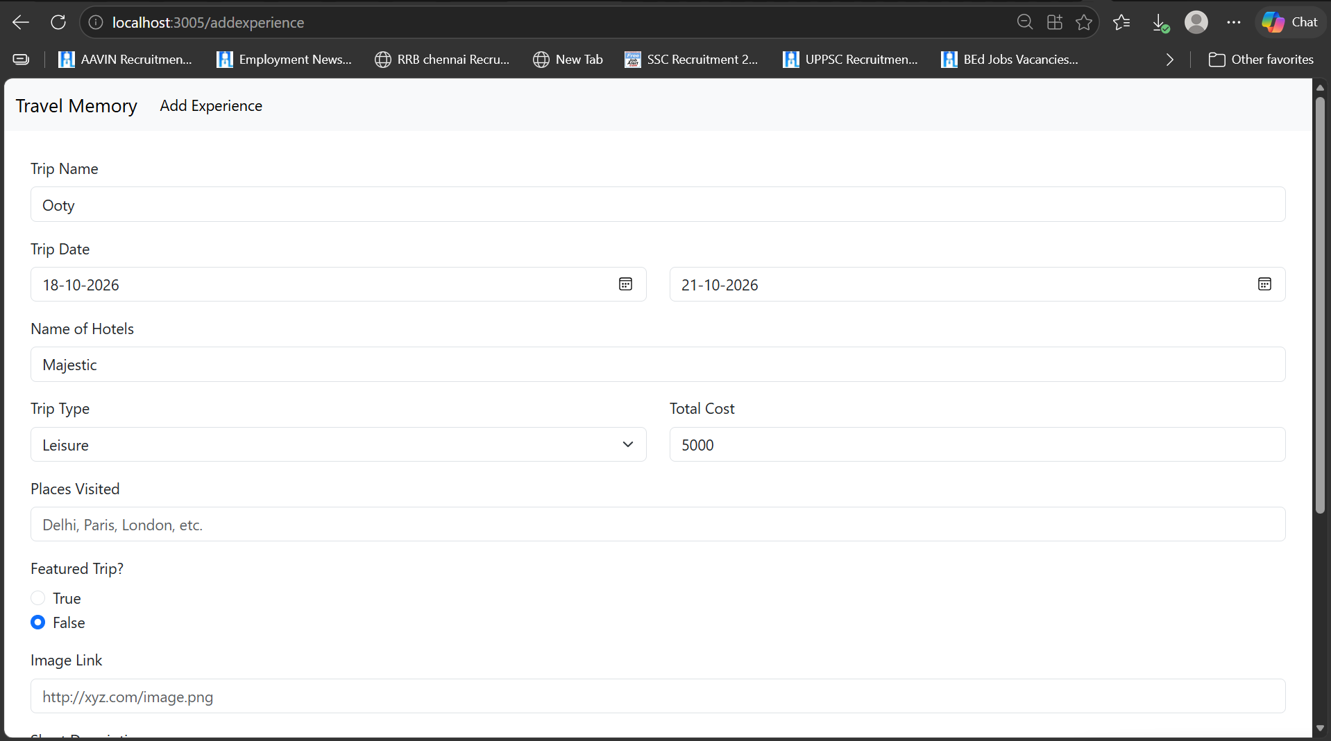
- Terraform Setup:
main.tf
data "aws_availability_zones" "available" {
state = "available"
}

data "aws_ami" "ubuntu" {
most_recent = true
owners = ["099720109477"] # Canonical

filter {
name = "name"
values = ["ubuntu/images/hvm-ssd/ubuntu-jammy-22.04-amd64-server-*"]
}

filter {
name = "virtualization-type"
values = ["hvm"]
}

filter {
name = "root-device-type"
values = ["ebs"]
}
}

locals {
name = var.project_name
tags = {
Project = var.project_name
ManagedBy = "Terraform"
}
}

resource "aws_vpc" "main" {
cidr_block = var.vpc_cidr
enable_dns_support = true
enable_dns_hostnames = true
tags = merge(local.tags, { Name = "${local.name}-vpc" })
}

resource "aws_internet_gateway" "igw" {
vpc_id = aws_vpc.main.id
tags = merge(local.tags, { Name = "${local.name}-igw" })
}

resource "aws_subnet" "public" {
vpc_id = aws_vpc.main.id
cidr_block = var.public_subnet_cidr
availability_zone = var.availability_zone
map_public_ip_on_launch = true
tags = merge(local.tags, { Name = "${local.name}-public-subnet" })
}

resource "aws_subnet" "private" {
vpc_id = aws_vpc.main.id
cidr_block = var.private_subnet_cidr
availability_zone = var.availability_zone
tags = merge(local.tags, { Name = "${local.name}-private-subnet" })
}

resource "aws_eip" "nat" {
domain = "vpc"
tags = merge(local.tags, { Name = "${local.name}-nat-eip" })
}

resource "aws_nat_gateway" "nat" {
allocation_id = aws_eip.nat.id
subnet_id = aws_subnet.public.id
depends_on = [aws_internet_gateway.igw]
tags = merge(local.tags, { Name = "${local.name}-nat" })
}

resource "aws_route_table" "public" {
vpc_id = aws_vpc.main.id
route {
cidr_block = "0.0.0.0/0"
gateway_id = aws_internet_gateway.igw.id
}
tags = merge(local.tags, { Name = "${local.name}-public-rt" })
}

resource "aws_route_table_association" "public" {
subnet_id = aws_subnet.public.id
route_table_id = aws_route_table.public.id
}

resource "aws_route_table" "private" {
vpc_id = aws_vpc.main.id
route {
cidr_block = "0.0.0.0/0"
nat_gateway_id = aws_nat_gateway.nat.id
}
tags = merge(local.tags, { Name = "${local.name}-private-rt" })
}

resource "aws_route_table_association" "private" {
subnet_id = aws_subnet.private.id
route_table_id = aws_route_table.private.id
}

resource "aws_security_group" "web" {
name = "${local.name}-web-sg"
description = "SSH from admin IP and public HTTP/HTTPS"
vpc_id = aws_vpc.main.id

ingress {
description = "SSH only from administrator IPv4"
from_port = 22
to_port = 22
protocol = "tcp"
cidr_blocks = [var.admin_cidr]
}

ingress {
description = "HTTP"
from_port = 80
to_port = 80
protocol = "tcp"
cidr_blocks = ["0.0.0.0/0"]
}

ingress {
description = "HTTPS"
from_port = 443
to_port = 443
protocol = "tcp"
cidr_blocks = ["0.0.0.0/0"]
}

egress {
from_port = 0
to_port = 0
protocol = "-1"
cidr_blocks = ["0.0.0.0/0"]
}

tags = merge(local.tags, { Name = "${local.name}-web-sg" })
}

resource "aws_security_group" "db" {
name = "${local.name}-db-sg"
description = "MongoDB only from web server; SSH via web server"
vpc_id = aws_vpc.main.id

ingress {
description = "MongoDB from web EC2 only"
from_port = 27017
to_port = 27017
protocol = "tcp"
security_groups = [aws_security_group.web.id]
}

ingress {
description = "SSH from web EC2 jump host"
from_port = 22
to_port = 22
protocol = "tcp"
security_groups = [aws_security_group.web.id]
}

egress {
from_port = 0
to_port = 0
protocol = "-1"
cidr_blocks = ["0.0.0.0/0"]
}

tags = merge(local.tags, { Name = "${local.name}-db-sg" })
}

resource "aws_iam_role" "ec2" {
name = "${local.name}-ec2-role"
assume_role_policy = jsonencode({
Version = "2012-10-17"
Statement = [{
Effect = "Allow"
Principal = { Service = "ec2.amazonaws.com" }
Action = "sts:AssumeRole"
}]
})
tags = local.tags
}

resource "aws_iam_instance_profile" "ec2" {
name = "${local.name}-instance-profile"
role = aws_iam_role.ec2.name
}

resource "aws_instance" "web" {
ami = data.aws_ami.ubuntu.id
instance_type = var.web_instance_type
subnet_id = aws_subnet.public.id
vpc_security_group_ids = [aws_security_group.web.id]
key_name = var.key_name
associate_public_ip_address = true
iam_instance_profile = aws_iam_instance_profile.ec2.name

root_block_device {
volume_size = var.root_volume_size
volume_type = "gp3"
encrypted = true
delete_on_termination = true
}

metadata_options {
http_endpoint = "enabled"
http_tokens = "required"
}

tags = merge(local.tags, { Name = "${local.name}-web" })
}

resource "aws_instance" "db" {
ami = data.aws_ami.ubuntu.id
instance_type = var.db_instance_type
subnet_id = aws_subnet.private.id
vpc_security_group_ids = [aws_security_group.db.id]
key_name = var.key_name
iam_instance_profile = aws_iam_instance_profile.ec2.name

root_block_device {
volume_size = var.root_volume_size
volume_type = "gp3"
encrypted = true
delete_on_termination = true
}

metadata_options {
http_endpoint = "enabled"
http_tokens = "required"
}

tags = merge(local.tags, { Name = "${local.name}-db" })
}
Variable.tf:
variable "aws_region" {
description = "AWS region for this deployment"
type = string
default = "us-east-1"
}

variable "project_name" {
type = string
default = "travelmemory"
}

variable "vpc_cidr" {
type = string
default = "10.20.0.0/16"
}

variable "public_subnet_cidr" {
type = string
default = "10.20.1.0/24"
}

variable "private_subnet_cidr" {
type = string
default = "10.20.2.0/24"
}

variable "availability_zone" {
description = "AZ in the selected region, e.g. us-east-1a"
type = string
default = "us-east-1a"
}

variable "key_name" {
description = "Name of an existing EC2 key pair in aws_region"
type = string
}

variable "admin_cidr" {
description = "Your current public IPv4 CIDR for SSH, e.g. 203.0.113.10/32"
type = string
validation {
condition = can(cidrhost(var.admin_cidr, 0)) && endswith(var.admin_cidr, "/32")
error_message = "Use a single IPv4 address with /32, for example 198.51.100.25/32."
}
}

variable "web_instance_type" {
type = string
default = "t3.micro"
}

variable "db_instance_type" {
type = string
default = "t3.micro"
}

variable "root_volume_size" {
type = number
default = 12
}
version.tf:
terraform {
required_version = ">= 1.5.0"
required_providers {
aws = {
source = "hashicorp/aws"
version = "~> 5.0"
}
}
}

provider "aws" {
region = var.aws_region
}
output.tf:
output "web_public_ip" {
description = "Public IPv4 address of the web/application EC2 instance"
value = aws_instance.web.public_ip
}

output "web_public_dns" {
value = aws_instance.web.public_dns
}

output "db_private_ip" {
description = "Private IPv4 address of the MongoDB EC2 instance"
value = aws_instance.db.private_ip
}

output "vpc_id" {
value = aws_vpc.main.id
}

output "public_subnet_id" {
value = aws_subnet.public.id
}

output "private_subnet_id" {
value = aws_subnet.private.id
}
terraform.tfvars:
aws_region = "us-east-1"
project_name = "travelmemory"
availability_zone = "us-east-1a"
key_name = "travelmemory-terraform-key"
admin_cidr = "49.205.10.25/32"
web_instance_type = "t3.micro"
db_instance_type = "t3.micro"
root_volume_size = 12
- Terraform Output:
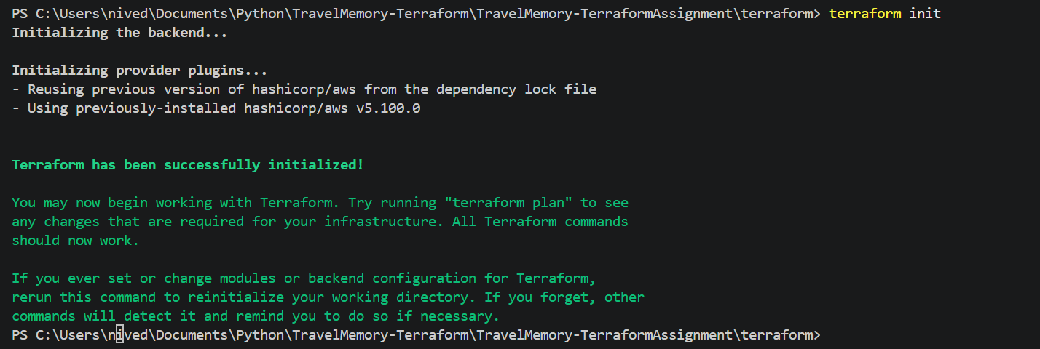
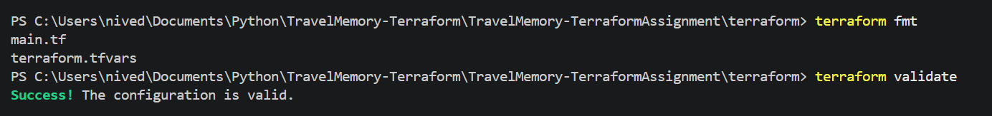
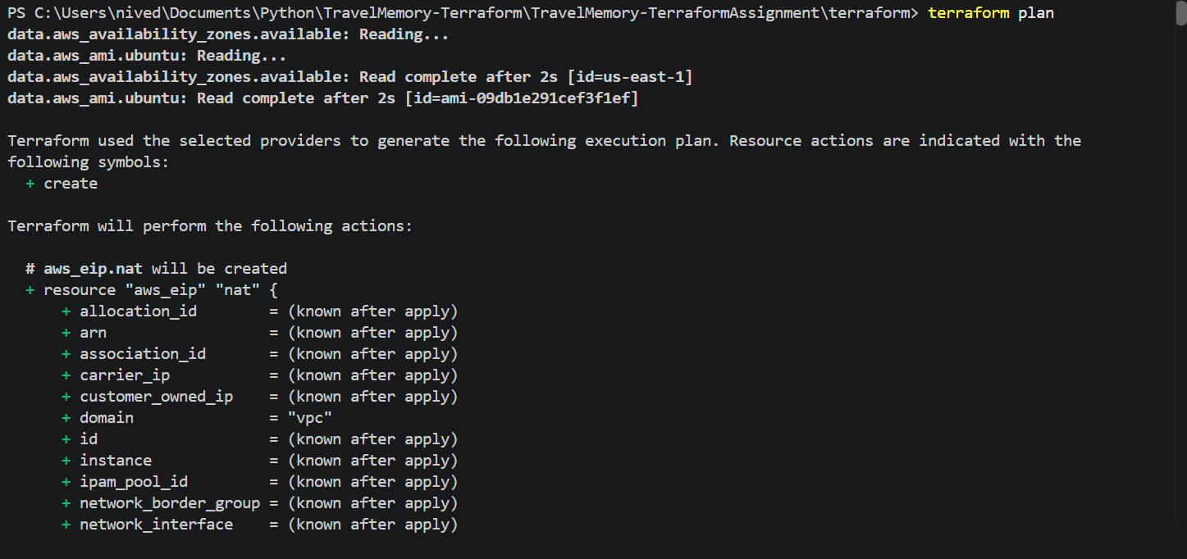
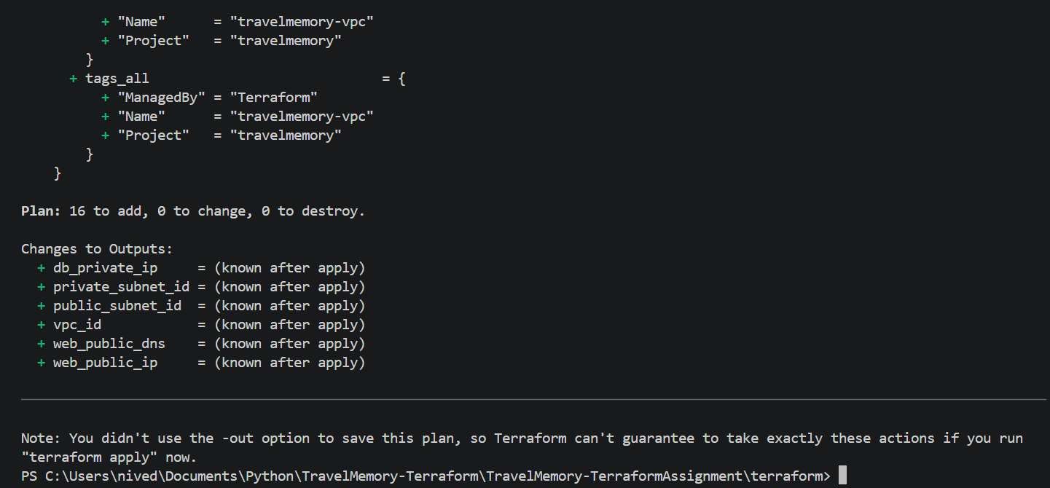
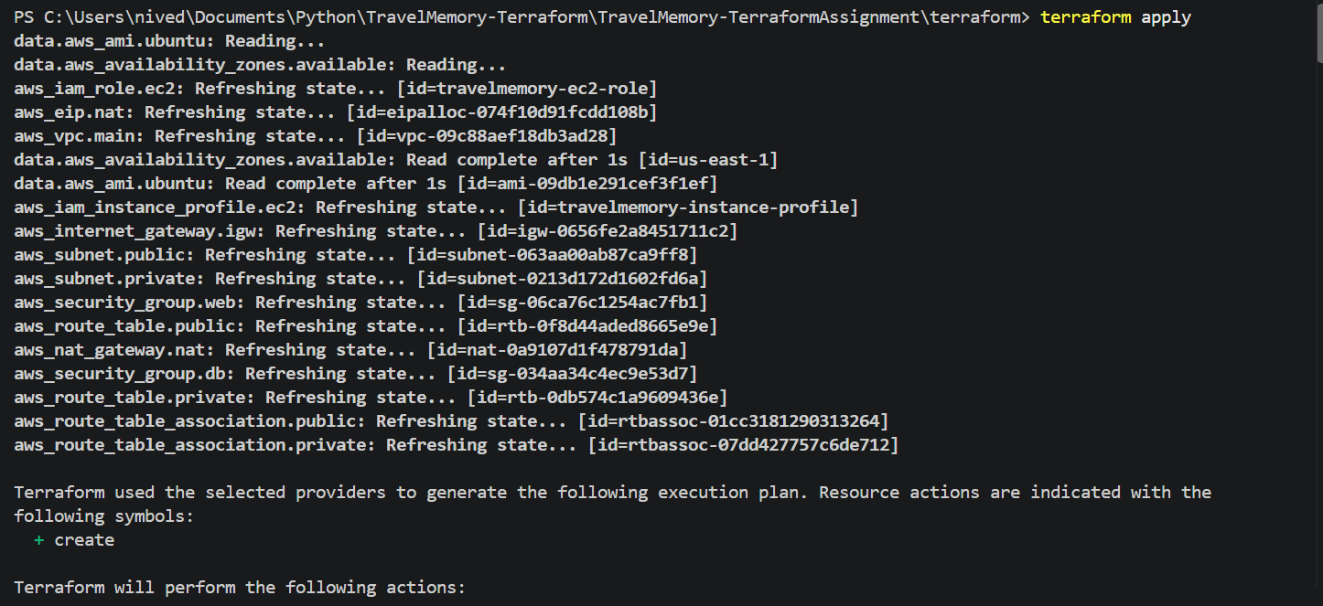
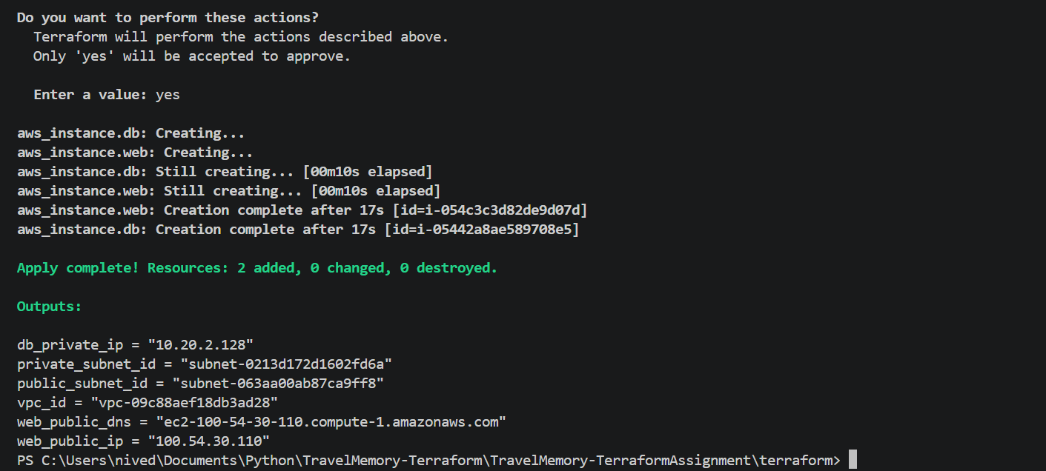
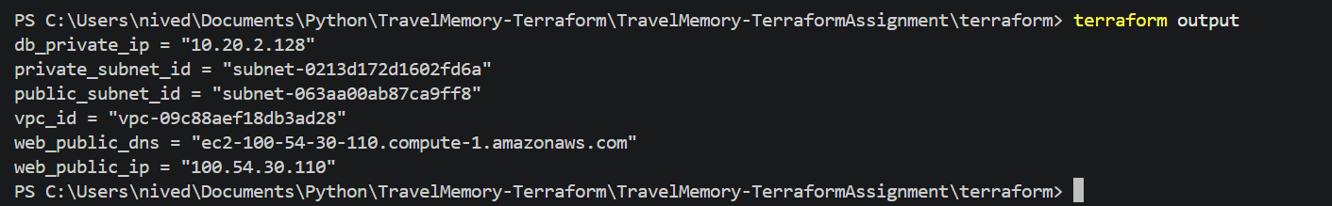
- Verification:
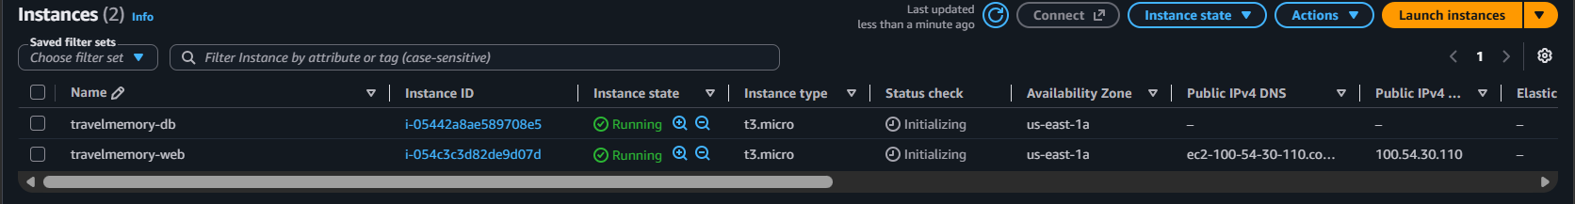
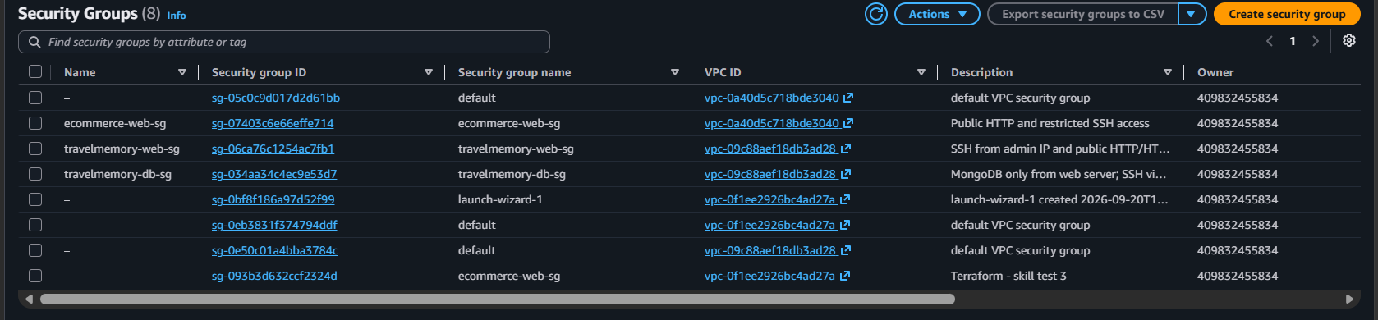
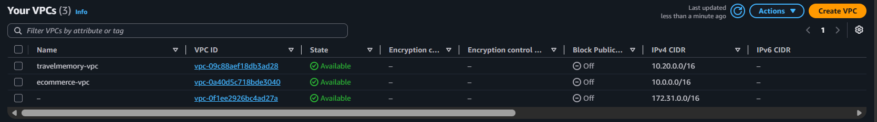
Part 2: Configuration and Deployment with Ansible:
- Make the EC2 private key available in WSL
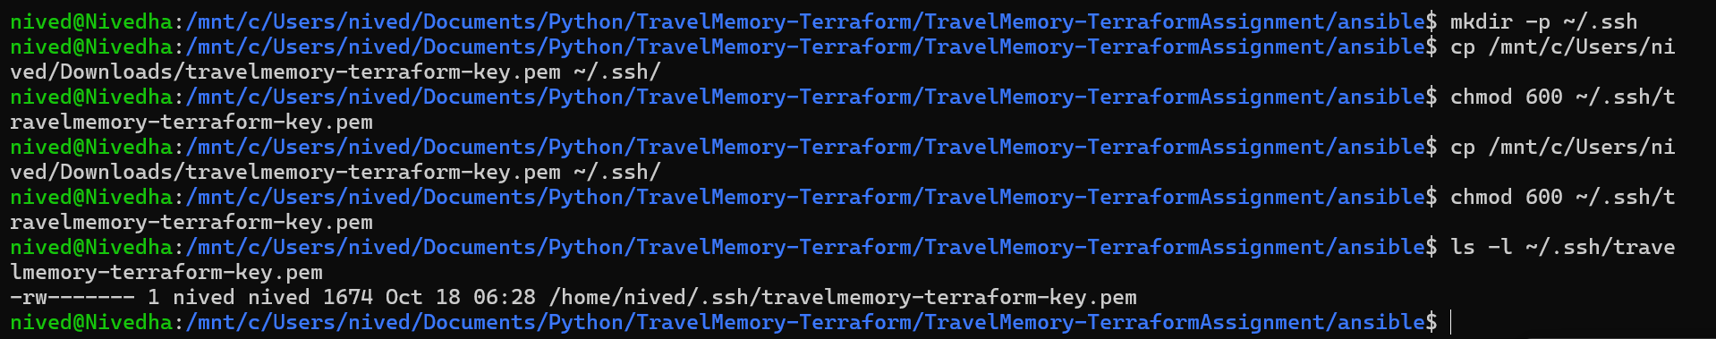
- Configure the Ansible inventory and verify:
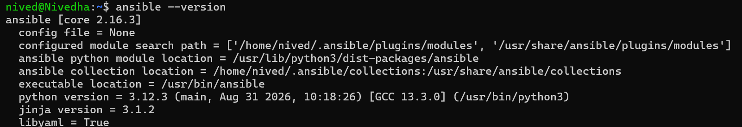
create ansible files:
inventory.ini:
[web]
web1 ansible_host=100.54.30.110 ansible_user=ubuntu ansible_ssh_private_key_file=/home/nived/.ssh/travelmemory-terraform-key.pem

[db]
db1 ansible_host=10.20.2.128 ansible_user=ubuntu ansible_ssh_private_key_file=/home/nived/.ssh/travelmemory-terraform-key.pem ansible_ssh_common_args='-o ProxyCommand="ssh -i /home/nived/.ssh/travelmemory-terraform-key.pem -o IdentitiesOnly=yes -W %h:%p ubuntu@100.54.30.110"'

[all:vars]
ansible_python_interpreter=/usr/bin/python3
ansible.cfg:
[defaults]
host_key_checking = True
retry_files_enabled = False
interpreter_python = auto_silent
timeout = 30

[ssh_connection]
pipelining = True

group_vars/all.yml:
app_repo: "https://github.com/UnpredictablePrashant/TravelMemory.git"
app_root: "/opt/travelmemory"
node_major: "20"
mongo_database: "travelmemory"
mongo_app_user: "admin"
# Replace this before encrypting the file with ansible-vault.
mongo_app_password: "travelAdmin"
backend_port: 3001
templates/backend.env.j2:
PORT={{ backend_port }}
NODE_ENV=production
MONGO_URI=mongodb://{{ mongo_app_user }}:{{ mongo_app_password | urlencode }}@{{ hostvars[groups['db'][0]].ansible_host }}:27017/{{ mongo_database }}?authSource=admin
templates/mongod.conf.j2:
# Managed by Ansible
storage:
dbPath: /var/lib/mongodb
systemLog:
destination: file
logAppend: true
path: /var/log/mongodb/mongod.log
net:
port: 27017
bindIp: 127.0.0.1,{{ hostvars[inventory_hostname].ansible_host }}
processManagement:
timeZoneInfo: /usr/share/zoneinfo
security:
authorization: enabled

templates/nginx-travelmemory.conf.j2:
server {
listen 80 default_server;
listen [::]:80 default_server;
server_name _;

root /var/www/travelmemory;
index index.html;

add_header X-Content-Type-Options nosniff always;
add_header X-Frame-Options SAMEORIGIN always;
add_header Referrer-Policy strict-origin-when-cross-origin always;

location /api/ {
proxy_pass http://127.0.0.1:{{ backend_port }}/;
proxy_http_version 1.1;
proxy_set_header Host $host;
proxy_set_header X-Real-IP $remote_addr;
proxy_set_header X-Forwarded-For $proxy_add_x_forwarded_for;
proxy_set_header X-Forwarded-Proto $scheme;
}

location / {
try_files $uri $uri/ /index.html;
}
}

templates/travelmemory.service.j2:
[Unit]
Description=TravelMemory Express backend
After=network-online.target
Wants=network-online.target

[Service]
Type=simple
User=ubuntu
Group=ubuntu
WorkingDirectory={{ app_root }}/source/backend
EnvironmentFile={{ app_root }}/source/backend/.env
ExecStart=/usr/bin/node index.js
Restart=on-failure
RestartSec=5
NoNewPrivileges=true
PrivateTmp=true

[Install]
WantedBy=multi-user.target

site.yml:
---
- name: Configure MongoDB database server
hosts: db
become: true
vars_files:
- group_vars/all.yml
tasks:
- name: Install required packages
ansible.builtin.apt:
name:
- gnupg
- curl
- ca-certificates
state: present
update_cache: true

- name: Add MongoDB 7.0 signing key
ansible.builtin.shell: |
set -o pipefail
curl -fsSL https://pgp.mongodb.com/server-7.0.asc | gpg --dearmor -o /usr/share/keyrings/mongodb-server-7.0.gpg
args:
creates: /usr/share/keyrings/mongodb-server-7.0.gpg
executable: /bin/bash

- name: Add MongoDB 7.0 repository
ansible.builtin.apt_repository:
repo: "deb [ arch=amd64,arm64 signed-by=/usr/share/keyrings/mongodb-server-7.0.gpg ] https://repo.mongodb.org/apt/ubuntu jammy/mongodb-org/7.0 multiverse"
filename: mongodb-org-7.0
state: present

- name: Install MongoDB
ansible.builtin.apt:
name: mongodb-org
state: present
update_cache: true

- name: Configure MongoDB to listen on localhost and private interface
ansible.builtin.template:
src: templates/mongod.conf.j2
dest: /etc/mongod.conf
owner: root
group: root
mode: "0644"
notify: Restart MongoDB

- name: Ensure MongoDB is enabled and started
ansible.builtin.systemd:
name: mongod
enabled: true
state: started

- name: Apply MongoDB configuration before creating credentials
ansible.builtin.meta: flush_handlers

- name: Wait for MongoDB to accept connections
ansible.builtin.wait_for:
port: 27017
host: 127.0.0.1
timeout: 90

- name: Create application database user (MongoDB localhost exception applies on first setup)
ansible.builtin.shell: |
mongosh --quiet admin --eval '
if (db.getUser("{{ mongo_app_user }}") === null) {
db.createUser({
user: "{{ mongo_app_user }}",
pwd: "{{ mongo_app_password | replace("\\", "\\\\") | replace("\"", "\\\"") }}",
roles: [{ role: "readWrite", db: "{{ mongo_database }}" }]
});
}'
args:
executable: /bin/bash
no_log: true
register: mongo_user_result
changed_when: "'created' in (mongo_user_result.stdout | default(''))"
failed_when: mongo_user_result.rc != 0

handlers:
- name: Restart MongoDB
ansible.builtin.systemd:
name: mongod
state: restarted

- name: Deploy TravelMemory web and backend
hosts: web
become: true
vars_files:
- group_vars/all.yml
tasks:
- name: Install OS packages
ansible.builtin.apt:
name:
- ca-certificates
- curl
- git
- nginx
- build-essential
state: present
update_cache: true

- name: Add NodeSource Node.js repository
ansible.builtin.shell: |
curl -fsSL https://deb.nodesource.com/setup_{{ node_major }}.x | bash -
args:
creates: /etc/apt/sources.list.d/nodesource.list
executable: /bin/bash

- name: Install Node.js and npm
ansible.builtin.apt:
name: nodejs
state: present
update_cache: true

- name: Create application root
ansible.builtin.file:
path: "{{ app_root }}"
state: directory
owner: ubuntu
group: ubuntu
mode: "0755"

- name: Clone TravelMemory repository
ansible.builtin.git:
repo: "{{ app_repo }}"
dest: "{{ app_root }}/source"
version: main
update: true
become_user: ubuntu

- name: Install backend npm dependencies
ansible.builtin.command: npm install
args:
chdir: "{{ app_root }}/source/backend"
become_user: ubuntu

- name: Configure backend environment
ansible.builtin.template:
src: templates/backend.env.j2
dest: "{{ app_root }}/source/backend/.env"
owner: ubuntu
group: ubuntu
mode: "0600"
no_log: true
notify: Restart TravelMemory

- name: Install frontend npm dependencies
ansible.builtin.command: npm install
args:
chdir: "{{ app_root }}/source/frontend"
become_user: ubuntu

- name: Configure frontend build environment
ansible.builtin.copy:
dest: "{{ app_root }}/source/frontend/.env"
content: |
REACT_APP_BACKEND_URL=/api
owner: ubuntu
group: ubuntu
mode: "0644"

- name: Build React frontend
ansible.builtin.command: npm run build
args:
chdir: "{{ app_root }}/source/frontend"
become_user: ubuntu

- name: Install frontend build files
ansible.builtin.copy:
src: "{{ app_root }}/source/frontend/build/"
dest: /var/www/travelmemory/
remote_src: true
owner: www-data
group: www-data
mode: preserve

- name: Install Nginx site configuration
ansible.builtin.template:
src: templates/nginx-travelmemory.conf.j2
dest: /etc/nginx/sites-available/travelmemory
owner: root
group: root
mode: "0644"
notify: Reload Nginx

- name: Enable Nginx site
ansible.builtin.file:
src: /etc/nginx/sites-available/travelmemory
dest: /etc/nginx/sites-enabled/travelmemory
state: link
notify: Reload Nginx

- name: Disable default Nginx site
ansible.builtin.file:
path: /etc/nginx/sites-enabled/default
state: absent
notify: Reload Nginx

- name: Install systemd service for backend
ansible.builtin.template:
src: templates/travelmemory.service.j2
dest: /etc/systemd/system/travelmemory.service
owner: root
group: root
mode: "0644"
notify: Restart TravelMemory

- name: Enable and start backend
ansible.builtin.systemd:
name: travelmemory
enabled: true
state: started
daemon_reload: true

- name: Ensure Nginx is enabled and started
ansible.builtin.systemd:
name: nginx
enabled: true
state: started

- name: Validate Nginx configuration
ansible.builtin.command: nginx -t
changed_when: false

handlers:
- name: Restart TravelMemory
ansible.builtin.systemd:
name: travelmemory
state: restarted
daemon_reload: true
failed_when: false

- name: Reload Nginx
ansible.builtin.systemd:
name: nginx
state: reloaded
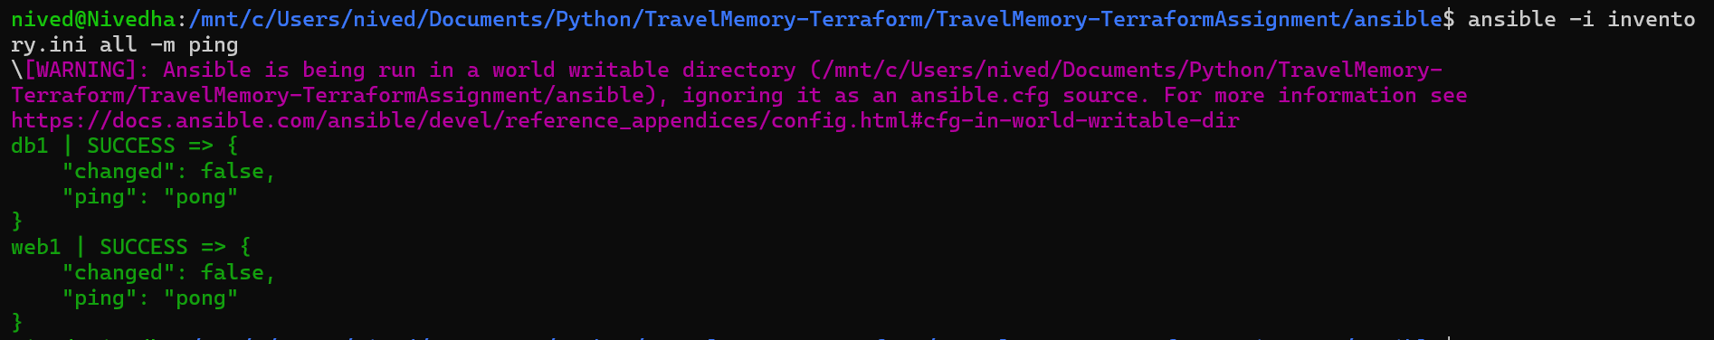
nived@Nivedha:/mnt/c/Users/nived/Documents/Python/TravelMemory-Terraform/TravelMemory-TerraformAssignment/ansible$ ansible-playbook -i inventory.ini site.yml --ask-vault-pass
[WARNING]: Ansible is being run in a world writable directory (/mnt/c/Users/nived/Documents/Python/TravelMemory-
Terraform/TravelMemory-TerraformAssignment/ansible), ignoring it as an ansible.cfg source. For more information see
https://docs.ansible.com/ansible/devel/reference_appendices/config.html#cfg-in-world-writable-dir
Vault password:

PLAY [Configure MongoDB database server] ********************************************************************************************

TASK [Gathering Facts] **************************************************************************************************************
ok: [db1]

TASK [Install required packages] ****************************************************************************************************
ok: [db1]

TASK [Add MongoDB 7.0 signing key] **************************************************************************************************
ok: [db1]

TASK [Add MongoDB 7.0 repository] ***************************************************************************************************
ok: [db1]

TASK [Install MongoDB] **************************************************************************************************************
ok: [db1]

TASK [Configure MongoDB to listen on localhost and private interface] ***************************************************************
ok: [db1]

TASK [Ensure MongoDB is enabled and started] ****************************************************************************************
ok: [db1]

TASK [Apply MongoDB configuration before creating credentials] **********************************************************************

TASK [Wait for MongoDB to accept connections] ***************************************************************************************
ok: [db1]
PLAY [Deploy TravelMemory application] *********************************************************************************************************************
skipping: no hosts matched


